From the High Commissioner’s Desk 21 February 2020

Getting Out into the Provinces
I mentioned in an earlier column that I would be making a point of getting out to visit the provinces of Solomon Islands as early as possible in my posting here. I did just that when I had the pleasure of visiting Auki at the end of January and Taro at the beginning of this month.
I was blown away by the hospitality and the lush green scenery I found in the small parts of Malaita and Choiseul I have visited so far.
In Auki, it was good to meet Premier Daniel Suidani. The Premier and I discussed the relationship between Australia and Malaita, and I underscored Australia’s recognition of the great importance of Malaita and Malaitans for the development and prosperity of the nation as a whole. We discussed the hydrographic survey of Bina Harbour (completed by the Australian Navy’s HMAS Leeuwin last year) and I was pleased to be able to advise the Premier that the data collected during that survey was being analysed and refined in Australia, and should be ready for handing over to the Solomon Islands Government in March. Premier Suidani and I discussed the opportunities that the Coral Sea Cable would offer Malaita in terms of business, government services, education and health. The Premier was appreciative of Australia’s ongoing support to Malaita. We discussed Australia’s development program activities in Malaita across the education, health, gender equality, justice, and economic development sectors.
I was especially pleased to discuss with the Premier the importance Australia places on striving to achieve gender equality: after all, the global data shows that the full potential of a nation can’t be achieved without empowering women to participate in the economy and leadership of a country. I was delighted to hear from Premier Suidani that the Malaita Provincial Government shares this priority. This seems like a wonderful legacy for the Premier to build throughout his term, though of course making real progress will not be easy. Australia is ready to work with Malaita (and indeed all of the provinces) wherever there is commitment to finding ways to support women and providing opportunities for women to rise up as Solomon Islands’ future leaders, including as national and provincial MPs.
It was good to get the chance to see firsthand Australia’s assistance on the ground in Malaita. I visited the Auki Women’s’ Resource Centre to learn about the work being done by the Centre, the Provincial Women’s Development Officer and Oxfam’s Safe Families program to end violence against women and girls and to empower the women of Malaita. A visit to the Auki Market also provided an opportunity to meet market vendors whose livelihoods have been improved through the UN Women Markets for Change program. Australia is proud to support these programs.
The most fun moment of the day was sitting with a group of preschool kids at the Kwaibala Early Childhood Development Centre, reading them a story. Kwaibala is supported by Australia through Save the Children's Play to be School Ready program. It was a delightful experience for me and I think the kids enjoyed it too!
I also had the chance to see and hear work done in the justice and health sectors in the province and the challenges they face to deliver services. I am impressed by the commitment shown by the workers in both these sectors despite being up against some significant challenges.
The Taro visit was to open the third domestic cable landing station in Solomon Islands. I was accompanied by a high-level delegation from the Solomon Islands Government led by the Prime Minister himself, the Hon Manasseh Sogavare. Prime Minister Sogavare and I were accompanied by my colleague, New Zealand High Commissioner Georgina Roberts. The Hon Peter Shanel Akovaka, the Hon Harry Kuma and the Hon Robertson Galokale were part of the delegation.
The cable significantly improves internet access and will provide new opportunities for the men and women living in Taro, with access to online learning and professional development opportunities, as well as improved government and health services. Taro will experience faster, more affordable and more reliable internet than ever before.
Speaking at the opening of the landing station, Prime Minister Sogavare described the cable as a game changer in Solomon Islands, bringing the country into the 21st century, transforming the lives of those in the rural areas. Australia is proud to be at the heart of such a momentous development for Solomon Islands.
I also had the opportunity to formally hand over seven water tanks to the Sipozae community under the Australian High Commission’s Direct Aid Program. Our development assistance ranges from very large to very small scale and it was great to witness how even small projects like the one in Sipozae can improve the lives of women and children, who had previously wlked long distances to collect water during droughts.
Choiseul and Malaita are both very important partners for Australia. We stand ready to work with them and with all other provinces in the Solomon Islands to help them deliver important services and create opportunity for ordinary Solomon Islanders.
ENDS//
Media enquiries: Grace Williams, Australian High Commission Phone: 21561 ext 278, Email Grace.Williams@dfat.gov.au
3 Photos attached;
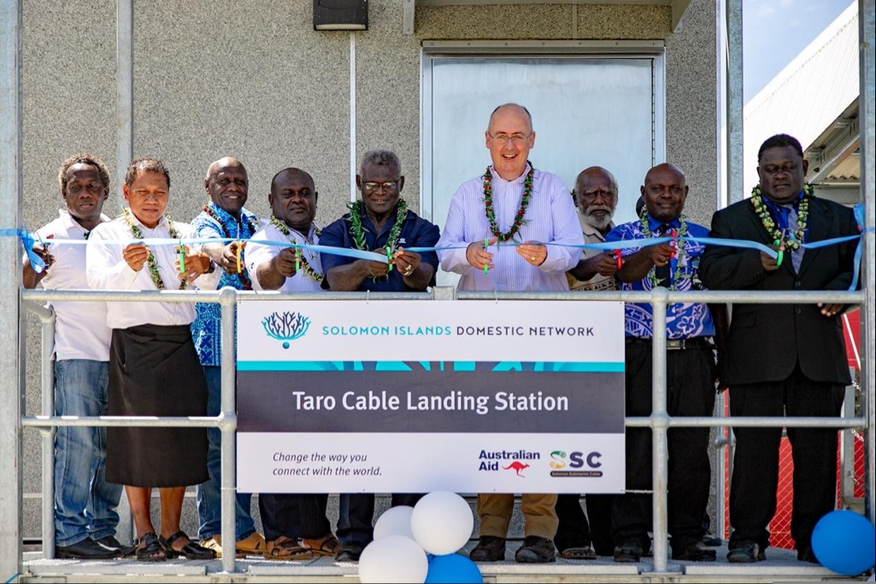
Caption: Opening the Taro Cable Landing Station with Prime Minister Sogavare, and his government Ministers, Choiseul Premier Watson Qoloni and Landowners of Lauru

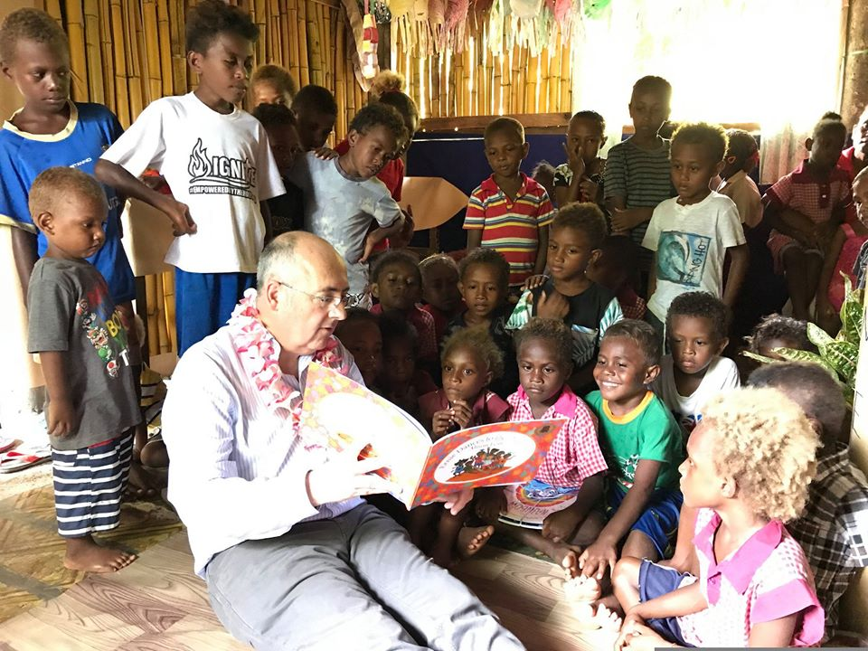
Caption: Reading to preschool kids at the Kwaibala Early Childhood Development Centre

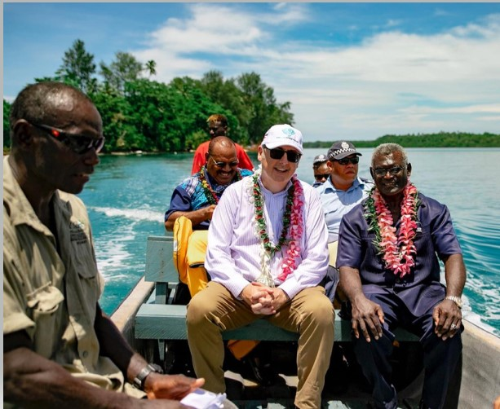
Caption: Chatting with Prime Minister Sogavare on a short boat trip from Sipozae Islands back to Taro after handing over a DAP Project to communities on Sipozae.

